**Problem Solving:**

When in import the DataFrames to PostgresSQL using the “to_sql”, it automatically created all the tables in SQL.

However, SQL has automatically added double quotes to column identifiers.

**Query attempt:**

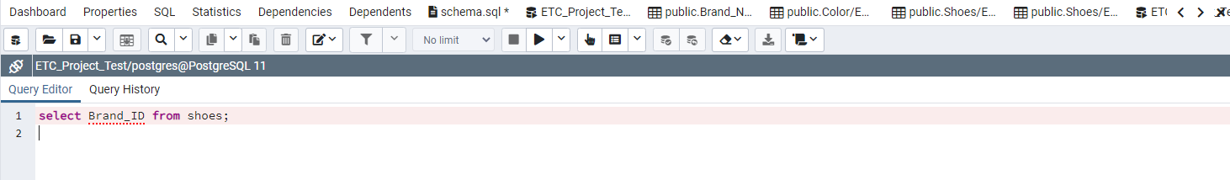

**Error Message:**

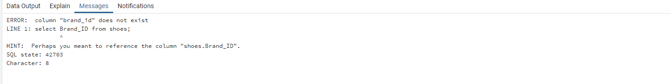

**Query attempt:**

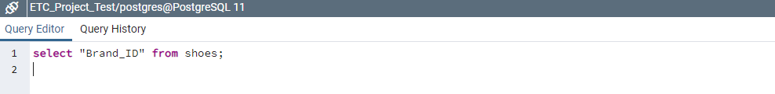

**Output:**

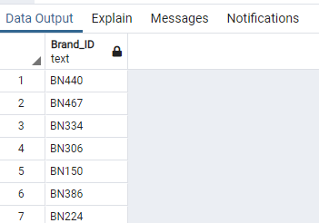

Query attempt:

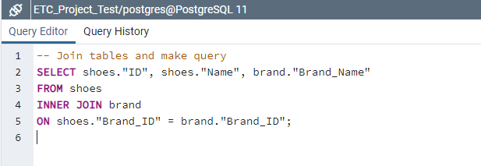

**Output:**

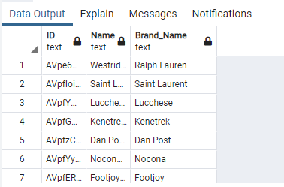

To solve this double quoting issue and make the database easier to make query in future, I’ve converted the dataframe columns to lower_case using Pandas before importing to SQL.

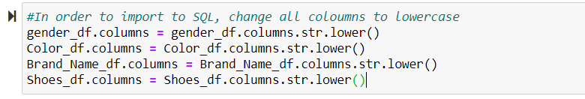

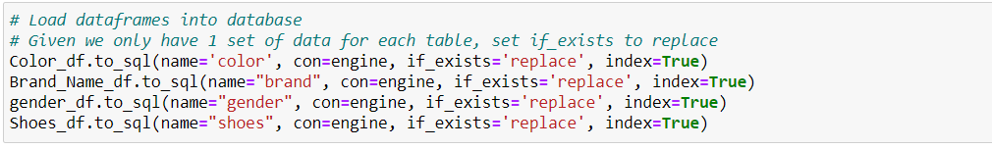

Query Attempt:

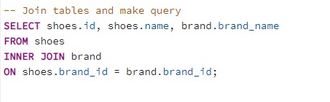

**Output:**

